***This is a bonus Web chapter
CHAPTER 38

Menus, Toolbars, and Dialogs

Objectives
- To create menus using components JMenuBar, JMenu, JMenuItem, JCheckBoxMenuItem, and JRadioButtonMenuItem (§38.2).
- To create popup menus using components JPopupMenu, JMenuItem, JCheckBoxMenuItem, and JRadioButtonMenuItem (§38.3).
- To use JToolBar to create toolbars (§38.4).
- To use Action objects to generalize the code for processing actions (§38.5).
- To create standard dialogs using the JOptionPane class (§38.6).
- To extend the JDialog class to create custom dialogs (§38.7).
- To select colors using JColorChooser (§38.8).
- To use JFileChooser to display Open and Save File dialogs (§38.9).
38.1 Introduction
Java provides a comprehensive solution for building graphical user interfaces. This chapter introduces menus, popup menus, toolbars, and dialogs. You will also learn how to use Action objects to generalize the code for processing actions.

38.2 Menus
<margin note: menu>
Menus make selection easier and are widely used in window applications. Java provides five classes that implement menus: JMenuBar, JMenu, JMenuItem, JCheckBoxMenuItem, and JRadioButtonMenuItem.

<margin note: menu item>
JMenuBar is a top-level menu component used to hold the menus. A menu consists of menu items that the user can select (or toggle on or off). A menu item can be an instance of JMenuItem, JCheckBoxMenuItem, or JRadioButtonMenuItem. Menu items can be associated with icons, keyboard mnemonics, and keyboard accelerators. Menu items can be separated using separators.

38.2.1 Creating Menus
The sequence of implementing menus in Java is as follows:

1. Create a menu bar and associate it with a frame or an applet by using the setJMenuBar method. For example, the following code creates a frame and a menu bar, and sets the menu bar in the frame:

JFrame frame = new JFrame();
frame.setSize(300, 200);
frame.setVisible(true);

JMenuBar jmb = new JMenuBar();
frame.setJMenuBar(jmb); // Attach a menu bar to a frame

2. Create menus and associate them with the menu bar.
You can use the following constructor to create a menu:

public JMenu(String label)

Here is an example of creating menus:

JMenu fileMenu = new JMenu("File");

JMenu helpMenu = new JMenu("Help");

This creates two menus labeled File and Help, as shown in Figure 38.1(a). The menus will not be seen until they are added to an instance of JMenuBar, as follows:
jmb.add(fileMenu);
jmb.add(helpMenu);

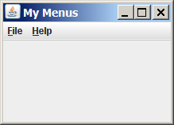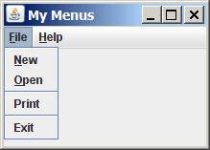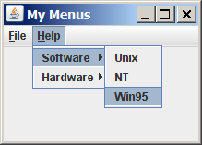

(a) (b) (c)

Figure 38.1
(a) The menu bar appears below the title bar on the frame. (b) Clicking a menu on the menu bar reveals the items under the menu. (c) Clicking a menu item reveals the submenu items under the menu item.

3. Create menu items and add them to the menus.

fileMenu.add(new JMenuItem("New"));
fileMenu.add(new JMenuItem("Open"));
fileMenu.addSeparator();
fileMenu.add(new JMenuItem("Print"));
fileMenu.addSeparator();
fileMenu.add(new JMenuItem("Exit"));

This code adds the menu items New, Open, a separator bar, Print, another separator bar, and Exit, in this order, to the File menu, as shown in Figure 38.1(b). The addSeparator() method adds a separator bar in the menu.

3.1. Creating submenu items.
You can also embed menus inside menus so that the embedded menus become submenus. Here is an example:

JMenu softwareHelpSubMenu = new JMenu("Software");

JMenu hardwareHelpSubMenu = new JMenu("Hardware");
helpMenu.add(softwareHelpSubMenu);
helpMenu.add(hardwareHelpSubMenu);
softwareHelpSubMenu.add(new JMenuItem("Unix"));
softwareHelpSubMenu.add(new JMenuItem("NT"));
softwareHelpSubMenu.add(new JMenuItem("Win95"));

This code adds two submenus, softwareHelpSubMenu and hardwareHelpSubMenu, in helpMenu. The menu items Unix, NT, and Win95 are added to softwareHelpSubMenu (see Figure 38.1(c)).

3.2. Creating check-box menu items.
You can also add a JCheckBoxMenuItem to a JMenu. JCheckBoxMenuItem is a subclass of JMenuItem that adds a Boolean state to the JMenuItem, and displays a check when its state is true. You can click a menu item to turn it on or off. For example, the following statement adds the check-box menu item Check it (see Figure 38.2(a)).

helpMenu.add(new JCheckBoxMenuItem("Check it"));

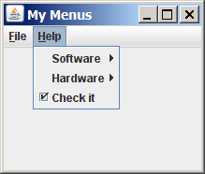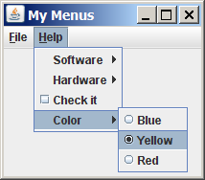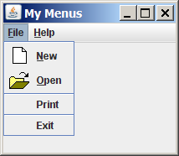

(a) (b) (c)

Figure 38.2
(a) A check box menu item lets you check or uncheck a menu item just like a check box. (b) You can use JRadioButtonMenuItem to choose among mutually exclusive menu choices. (c) You can set image icons, keyboard mnemonics, and keyboard accelerators in menus.

3.3. Creating radio-button menu items.
You can also add radio buttons to a menu, using the JRadioButtonMenuItem class. This is often useful when you have a group of mutually exclusive choices in the menu. For example, the following statements add a submenu named Color and a set of radio buttons for choosing a color (see Figure 38.2(b)):

JMenu colorHelpSubMenu = new JMenu("Color");
helpMenu.add(colorHelpSubMenu);

JRadioButtonMenuItem jrbmiBlue, jrbmiYellow, jrbmiRed;
colorHelpSubMenu.add(jrbmiBlue =
new JRadioButtonMenuItem("Blue"));
colorHelpSubMenu.add(jrbmiYellow =
new JRadioButtonMenuItem("Yellow"));
colorHelpSubMenu.add(jrbmiRed =
new JRadioButtonMenuItem("Red"));

ButtonGroup btg = new ButtonGroup();
btg.add(jrbmiBlue);
btg.add(jrbmiYellow);
btg.add(jrbmiRed);

4. The menu items generate ActionEvent. Your listener class must implement the ActionListener and the actionPerformed handler to respond to the menu selection.

38.2.2 Image Icons, Keyboard Mnemonics, and Keyboard Accelerators
The menu components JMenu, JMenuItem, JCheckBoxMenuItem, and JRadioButtonMenuItem have the icon and mnemonic properties. For example, using the following code, you can set icons for the New and Open menu items, and set keyboard mnemonics for File, Help, New, and Open:

JMenuItem jmiNew, jmiOpen;
fileMenu.add(jmiNew = new JMenuItem("New"));
fileMenu.add(jmiOpen = new JMenuItem("Open"));
jmiNew.setIcon(new ImageIcon("image/new.gif"));
jmiOpen.setIcon(new ImageIcon("image/open.gif"));
helpMenu.setMnemonic('H');
fileMenu.setMnemonic('F');
jmiNew.setMnemonic('N');
jmiOpen.setMnemonic('O');

The new icons and mnemonics are shown in Figure 38.2(c). You can also use JMenuItem constructors like the ones that follow to construct and set an icon or mnemonic in one statement.

public JMenuItem(String label, Icon icon);
public JMenuItem(String label, int mnemonic);

By default, the text is at the right of the icon. Use setHorizontalTextPosition(SwingConstants.LEFT) to set the text to the left of the icon.

<margin note: accelerator>
To select a menu, press the ALT key and the mnemonic key. For example, press ALT+F to select the File menu, and then press ALT+O to select the Open menu item. Keyboard mnemonics are useful, but they only let you select menu items from the currently open menu. Key accelerators, however, let you select a menu item directly by pressing the CTRL and accelerator keys. For example, by using the following code, you can attach the accelerator key CTRL+O to the Open menu item:

jmiOpen.setAccelerator(KeyStroke.getKeyStroke
(KeyEvent.VK_O, ActionEvent.CTRL_MASK));

The setAccelerator method takes a KeyStroke object. The static method getKeyStroke in the KeyStroke class creates an instance of the keystroke. VK_O is a constant representing the O key, and CTRL_MASK is a constant indicating that the CTRL key is associated with the keystroke.

NOTE: As shown in Figure 17.1, AbstractButton is the superclass for JButton and JMenuItem, and JMenuItem is a superclass for JCheckBoxMenuItem, JMenu, and JRadioButtonMenuItem. The menu components are very similar to buttons.

38.2.3 Example: Using Menus
This section gives an example that creates a user interface to perform arithmetic. The interface contains labels and text fields for Number 1, Number 2, and Result. The Result text field displays the result of the arithmetic operation between Number 1 and Number 2. Figure 38.3 contains a sample run of the program.

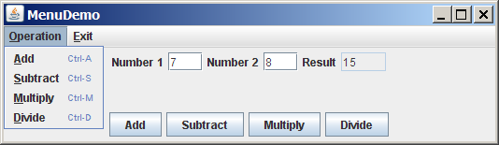

Figure 38.3
Arithmetic operations can be performed by clicking buttons or by choosing menu items from the Operation menu.

Here are the major steps in the program (Listing 38.1):
1. Create a menu bar and set it in the applet. Create the menus Operation and Exit, and add them to the menu bar. Add the menu items Add, Subtract, Multiply, and Divide under the Operation menu, and add the menu item Close under the Exit menu.
2. Create a panel to hold labels and text fields, and place the panel in the center of the applet.
3. Create a panel to hold the four buttons labeled Add, Subtract, Multiply, and Divide. Place the panel in the south of the applet.
4. Implement the actionPerformed handler to process the events from the menu items and the buttons.

Listing 38.1 MenuDemo.java
<margin note line 17: menu bar>
<margin note line 20: set menu bar>
<margin note line 28: exit menus>
<margin note line 33: add menu items>
<margin note line 40: accelerator>
<margin note line 61: buttons>
<margin note line 72: register listener>
<margin note line 78: register listener>
<margin note line 84: register listener>
<margin note line 90: register listener>
<margin note line 96: register listener>
<margin note line 102: register listener>
<margin note line 108: register listener>
<margin note line 114: register listener>
<margin note line 120: register listener>
<margin note line 129: calculator>
<margin note line 149: main method omitted>

1 import java.awt.*;
2 import java.awt.event.*;
3 import javax.swing.*;
4
5 public class MenuDemo extends JApplet {
6 // Text fields for Number 1, Number 2, and Result
7 private JTextField jtfNum1, jtfNum2, jtfResult;
8
9 // Buttons "Add", "Subtract", "Multiply" and "Divide"
10 private JButton jbtAdd, jbtSub, jbtMul, jbtDiv;
11
12 // Menu items "Add", "Subtract", "Multiply","Divide" and "Close"
13 private JMenuItem jmiAdd, jmiSub, jmiMul, jmiDiv, jmiClose;
14
15 public MenuDemo() {
16 // Create menu bar
17 JMenuBar jmb = new JMenuBar();
18
19 // Set menu bar to the applet
20 setJMenuBar(jmb);
21
22 // Add menu "Operation" to menu bar
23 JMenu operationMenu = new JMenu("Operation");
24 operationMenu.setMnemonic('O');
25 jmb.add(operationMenu);
26
27 // Add menu "Exit" to menu bar
28 JMenu exitMenu = new JMenu("Exit");
29 exitMenu.setMnemonic('E');
30 jmb.add(exitMenu);
31
32 // Add menu items with mnemonics to menu "Operation"
33 operationMenu.add(jmiAdd= new JMenuItem("Add", 'A'));
34 operationMenu.add(jmiSub = new JMenuItem("Subtract", 'S'));
35 operationMenu.add(jmiMul = new JMenuItem("Multiply", 'M'));
36 operationMenu.add(jmiDiv = new JMenuItem("Divide", 'D'));
37 exitMenu.add(jmiClose = new JMenuItem("Close", 'C'));
38
39 // Set keyboard accelerators
40 jmiAdd.setAccelerator(
41 KeyStroke.getKeyStroke(KeyEvent.VK_A, ActionEvent.CTRL_MASK));
42 jmiSub.setAccelerator(
43 KeyStroke.getKeyStroke(KeyEvent.VK_S, ActionEvent.CTRL_MASK));
44 jmiMul.setAccelerator(
45 KeyStroke.getKeyStroke(KeyEvent.VK_M, ActionEvent.CTRL_MASK));
46 jmiDiv.setAccelerator(
47 KeyStroke.getKeyStroke(KeyEvent.VK_D, ActionEvent.CTRL_MASK));
48
49 // Panel p1 to hold text fields and labels
50 JPanel p1 = new JPanel(new FlowLayout());
51 p1.add(new JLabel("Number 1"));
52 p1.add(jtfNum1 = new JTextField(3));
53 p1.add(new JLabel("Number 2"));
54 p1.add(jtfNum2 = new JTextField(3));
55 p1.add(new JLabel("Result"));
56 p1.add(jtfResult = new JTextField(4));
57 jtfResult.setEditable(false);
58
59 // Panel p2 to hold buttons
60 JPanel p2 = new JPanel(new FlowLayout());
61 p2.add(jbtAdd = new JButton("Add"));
62 p2.add(jbtSub = new JButton("Subtract"));
63 p2.add(jbtMul = new JButton("Multiply"));
64 p2.add(jbtDiv = new JButton("Divide"));
65
66 // Add panels to the frame
67 setLayout(new BorderLayout());
68 add(p1, BorderLayout.CENTER);
69 add(p2, BorderLayout.SOUTH);
70
71 // Register listeners
72 jbtAdd.addActionListener(new ActionListener() {
73 @Override
74 public void actionPerformed(ActionEvent e) {
75 calculate('+');
76 }
77 });
78 jbtSub.addActionListener(new ActionListener() {
79 @Override
80 public void actionPerformed(ActionEvent e) {
81 calculate('-');
82 }
83 });
84 jbtMul.addActionListener(new ActionListener() {
85 @Override
86 public void actionPerformed(ActionEvent e) {
87 calculate('*');
88 }
89 });
90 jbtDiv.addActionListener(new ActionListener() {
91 @Override
92 public void actionPerformed(ActionEvent e) {
93 calculate('/');
94 }
95 });
96 jmiAdd.addActionListener(new ActionListener() {
97 @Override
98 public void actionPerformed(ActionEvent e) {
99 calculate('+');
100 }
101 });
102 jmiSub.addActionListener(new ActionListener() {
103 @Override
104 public void actionPerformed(ActionEvent e) {
105 calculate('-');
106 }
107 });
108 jmiMul.addActionListener(new ActionListener() {
109 @Override
110 public void actionPerformed(ActionEvent e) {
111 calculate('*');
112 }
113 });
114 jmiDiv.addActionListener(new ActionListener() {
115 @Override
116 public void actionPerformed(ActionEvent e) {
117 calculate('/');
118 }
119 });
120 jmiClose.addActionListener(new ActionListener() {
121 @Override
122 public void actionPerformed(ActionEvent e) {
123 System.exit(1);
124 }
125 });
126 }
127
128 /** Calculate and show the result in jtfResult */
129 private void calculate(char operator) {
130 // Obtain Number 1 and Number 2
131 int num1 = (Integer.parseInt(jtfNum1.getText().trim()));
132 int num2 = (Integer.parseInt(jtfNum2.getText().trim()));
133 int result = 0;
134
135 // Perform selected operation
136 switch (operator) {
137 case '+': result = num1 + num2;
138 break;
139 case '-': result = num1 - num2;
140 break;
141 case '*': result = num1 * num2;
142 break;
143 case '/': result = num1 / num2;
144 }
145
146 // Set result in jtfResult
147 jtfResult.setText(String.valueOf(result));
148 }
149 }

The program creates a menu bar, jmb, which holds two menus: operationMenu and exitMenu (lines 17-30). The operationMenu contains four menu items for doing arithmetic: Add, Subtract, Multiply, and Divide. The exitMenu contains the menu item Close for exiting the program. The menu items in the Operation menu are created with keyboard mnemonics and accelerators.

The user enters two numbers in the number fields. When an operation is chosen from the menu, its result, involving two numbers, is displayed in the Result field. The user can also click the buttons to perform the same operation.

The private method calculate(char operator) (lines 129–148) retrieves operands from the text fields in Number 1 and Number 2, applies the binary operator on the operands, and sets the result in the Result text field.

NOTE:
<margin note: placing menus>
The menu bar is usually attached to the window using the setJMenuBar method. However, like any other component, it can be placed in a container. For instance, you can place a menu bar in the south of the container with BorderLayout.

38.3 Popup Menus
<margin note: popup menu>
A popup menu, also known as a context menu, is like a regular menu, but does not have a menu bar and can float anywhere on the screen. Creating a popup menu is similar to creating a regular menu. First, you create an instance of JPopupMenu, then you can add JMenuItem, JCheckBoxMenuItem, JRadioButtonMenuItem, and separators to the popup menu. For example, the following code creates a JPopupMenu and adds JMenuItems into it:

JPopupMenu jPopupMenu = new JPopupMenu();
jPopupMenu.add(new JMenuItem("New"));
jPopupMenu.add(new JMenuItem("Open"));

A regular menu is always attached to a menu bar using the setJMenuBar method, but a popup menu is associated with a parent component and is displayed using the show method in the JPopupMenu class. You specify the parent component and the location of the popup menu, using the coordinate system of the parent like this:

jPopupMenu.show(component, x, y);
<margin note: popup trigger>
Customarily, you display a popup menu by pointing to a GUI component and clicking a certain mouse button, the so-called popup trigger. Popup triggers are system dependent. In Windows, the popup menu is displayed when the right mouse button is released. In Motif, the popup menu is displayed when the third mouse button is pressed and held down.

Listing 38.2 gives an example that creates a text area in a scroll pane. When the mouse points to the text area, clicking a mouse button displays a popup menu, as shown in Figure 38.4.

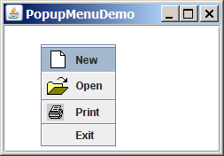

Figure 38.4
A popup menu is displayed when the popup trigger is issued on the text area.

Here are the major steps in the program (Listing 38.2):
- Create a popup menu using JPopupMenu. Create menu items for New, Open, Print, and Exit using JMenuItem. For the menu items with both labels and icons, it is convenient to use the JMenuItem(label, icon) constructor.
- Add the menu items into the popup menu.
- Create a scroll pane and add a text area into it. Place the scroll pane in the center of the applet.
- Implement the actionPerformed handler to process the events from the menu items.
- Implement the mousePressed and mouseReleased methods to process the events for handling popup triggers.

Listing 38.2 PopupMenuDemo.java
<margin note line 6: popup menu>
<margin note line 17: add menu items>
<margin note line 27: register listener>
<margin note line 33: register listener>
<margin note line 39: register listener>
<margin note line 45: register listener>
<margin note line 54: show popup menu>
<margin note line 59: show popup menu>
<margin note line 69: main method omitted>

1 import javax.swing.*;
2 import java.awt.*;
3 import java.awt.event.*;
4
5 public class PopupMenuDemo extends JApplet {
6 private JPopupMenu jPopupMenu1 = new JPopupMenu();
7 private JMenuItem jmiNew = new JMenuItem("New",
8 new ImageIcon(getClass().getResource("image/new.gif")));
9 private JMenuItem jmiOpen = new JMenuItem("Open",
10 new ImageIcon(getClass().getResource("image/open.gif")));
11 private JMenuItem jmiPrint = new JMenuItem("Print",
12 new ImageIcon(getClass().getResource("image/print.gif")));
13 private JMenuItem jmiExit = new JMenuItem("Exit");
14 private JTextArea jTextArea1 = new JTextArea();
15
16 public PopupMenuDemo() {
17 jPopupMenu1.add(jmiNew);
18 jPopupMenu1.add(jmiOpen);
19 jPopupMenu1.addSeparator();
20 jPopupMenu1.add(jmiPrint);
21 jPopupMenu1.addSeparator();
22 jPopupMenu1.add(jmiExit);
23 jPopupMenu1.add(jmiExit);
24
25 add(new JScrollPane(jTextArea1), BorderLayout.CENTER);
26
27 jmiNew.addActionListener(new ActionListener() {
28 @Override
29 public void actionPerformed(ActionEvent e) {
30 System.out.println("Process New");
31 }
32 });
33 jmiOpen.addActionListener(new ActionListener() {
34 @Override
35 public void actionPerformed(ActionEvent e) {
36 System.out.println("Process Open");
37 }
38 });
39 jmiPrint.addActionListener(new ActionListener() {
40 @Override
41 public void actionPerformed(ActionEvent e) {
42 System.out.println("Process Print");
43 }
44 });
45 jmiExit.addActionListener(new ActionListener() {
46 @Override
47 public void actionPerformed(ActionEvent e) {
48 System.exit(1);
49 }
50 });
51 jTextArea1.addMouseListener(new MouseAdapter() {
52 @Override
53 public void mousePressed(MouseEvent e) { // For Motif
54 showPopup(e);
55 }
56
57 @Override
58 public void mouseReleased(MouseEvent e) { // For Windows
59 showPopup(e);
60 }
61 });
62 }
63
64 /** Display popup menu when triggered */
65 private void showPopup(java.awt.event.MouseEvent evt) {
66 if (evt.isPopupTrigger())
67 jPopupMenu1.show(evt.getComponent(), evt.getX(), evt.getY());
68 }
69 }

The process of creating popup menus is similar to the process for creating regular menus. To create a popup menu, create a JPopupMenu as the basis (line 6) and add JMenuItems to it (lines 17-23).

To show a popup menu, use the show method by specifying the parent component and the location for the popup menu (line 61). The show method is invoked when the popup menu is triggered by a particular mouse click on the text area. Popup triggers are system dependent. The listener implements the mouseReleased handler for displaying the popup menu in Windows (lines 52-54) and the mousePressed handler for displaying the popup menu in Motif (lines 48-50).

TIP
<margin note: simplify popup menu>
Java provides a new setComponentPopupMenu(JPopupMenu) method in the JComponent class, which can be used to add a popup menu on a component. This method automatically handles mouse listener registration and popup display. Using this method, you may delete the showPopup method in lines 59-62 and replace the code in lines 47-55 with the following statement:

jTextArea1.setComponentPopupMenu(jPopupMenu1);

***End of TIP

38.4 JToolBar
<margin note: toolbar>
In user interfaces, a toolbar is often used to hold commands that also appear in the menus. Frequently used commands are placed in a toolbar for quick access. Clicking a command in the toolbar is faster than choosing it from the menu.

Swing provides the JToolBar class as the container to hold toolbar components. JToolBar uses BoxLayout to manage components by default. You can set a different layout manager if desired. The components usually appear as icons. Since icons are not components, they cannot be placed into a toolbar directly. Instead you place buttons into the toolbar and set the icons on the buttons. An instance of JToolBar is like a regular container. Often it is placed in the north, west, or east of a container of BorderLayout.

The following properties in the JToolBar class are often useful:
- orientation specifies whether the items in the toolbar appear horizontally or vertically. The possible values are JToolBar.HORIZONTAL and JToolBar.VERTICAL. The default value is JToolBar.HORIZONTAL.
- floatable is a boolean value that specifies whether the toolbar can be floated. By default, a toolbar is floatable.

Listing 38.3 gives an example that creates a JToolBar to hold three buttons with the icons representing the commands New, Open, and Print, as shown in Figure 38.5.

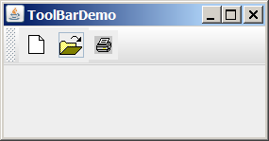

Figure 38.5
The toolbar contains the icons representing the commands New, Open, and Print.

Listing 38.3 ToolBarDemo.java
<margin note line 6: buttons>
<margin note line 13: toolbar>
<margin note line 27: add toolbar>
<margin note line 29: main method omitted>

1 import javax.swing.*;
2 import java.awt.*;
3
4 public class ToolBarDemo extends JApplet {
5 private JButton jbtNew = new JButton(
6 new ImageIcon(getClass().getResource("/image/new.gif")));
7 private JButton jbtOpen = new JButton(
8 new ImageIcon(getClass().getResource("/image/open.gif")));
9 private JButton jbPrint = new JButton(
10 new ImageIcon(getClass().getResource("/image/print.gif")));
11
12 public ToolBarDemo() {
13 JToolBar jToolBar1 = new JToolBar("My Tool Bar");
14 jToolBar1.setFloatable(true);
15 jToolBar1.add(jbtNew);
16 jToolBar1.add(jbtOpen);
17 jToolBar1.add(jbPrint);
18
19 jbtNew.setToolTipText("New");
20 jbtOpen.setToolTipText("Open");
21 jbPrint.setToolTipText("Print");
22
23 jbtNew.setBorderPainted(false);
24 jbtOpen.setBorderPainted(false);
25 jbPrint.setBorderPainted(false);
26
27 add(jToolBar1, BorderLayout.NORTH);
28 }
29 }

A JToolBar is created in line 13. The toolbar is a container with BoxLayout by default. Using the orientation property, you can specify whether components in the toolbar are organized horizontally or vertically. By default, it is horizontal.

By default, the toolbar is floatable, and a floatable controller is displayed in front of its components. You can drag the floatable controller to move the toolbar to different locations of the window or can show the toolbar in a separate window, as shown in Figure 38.6.

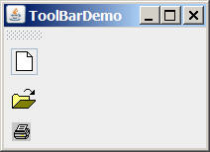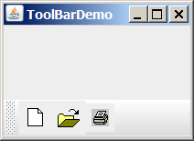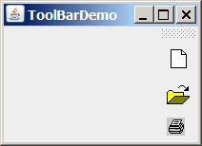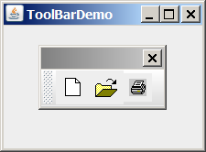

Figure 38.6

The toolbar buttons are floatable.

You can also set a title for the floatable toolbar, as shown in Figure 38.7(a). To do so, create a toolbar using the JToolBar(String title) constructor. If you set floatable false, the floatable controller is not displayed, as shown in Figure 38.7(b). If you set a border (e.g., a line border), as shown in Figure 38.7(c), the line border is displayed and the floatable controller is not displayed.

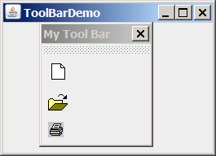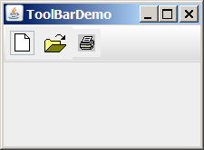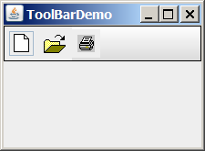
(a) (b) (c)

Figure 38.7

The toolbar buttons can be customized in many forms.

TIP: For the floatable feature to work properly, do the following: (1) place a toolbar to one side of the container of BorderLayout and add no components to the other sides; (2) don’t set border on a toolbar. Setting a border would make it non-floatable.

38.5 Processing Actions Using the Action Interface
Often menus and toolbars contain some common actions. For example, you can save a file by choosing File, Save, or by clicking the save button in the toolbar. Swing provides the Action interface, which can be used to create action objects for processing actions. Using Action objects, common action processing can be centralized and separated from the other application code.

The Action interface is a subinterface of ActionListener, as shown in Figure 38.8. Additionally, it defines several methods for checking whether the action is enabled, for enabling and disabling the action, and for retrieving and setting the associated action value using a key. The key can be any string, but four keys have predefined meanings:

Key Description
Action.NAME A name for the action
Action.SMALL_ICON A small icon for the action
Action.SHORT_DESCRIPTION A tool tip for the action
Action.LONG_DESCRIPTION A description for online help

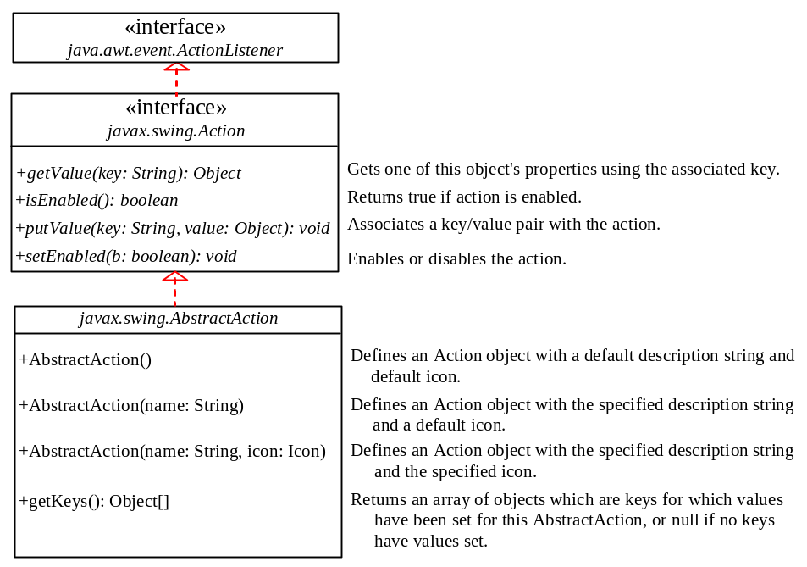

Figure 38.8
The Action interface provides a useful extension to the ActionListener interface in cases where the same functionality may be accessed by several controls. The AbstractAction class provides a default implementation for Action.

AbstractAction is a default implementation of the Action interface, as shown in Figure 38.8. It implements all the methods in the Action interface except the actionPerformed method. Additionally, it defines the getKeys() method.

Since AbstractAction is an abstract class, you cannot create an instance using its constructor. However, you can create a concrete subclass of AbstractAction and implement the actionPerformed method. This subclass can be conveniently defined as an anonymous inner class. For example, the following code creates an Action object for terminating a program.

Action exitAction = new AbstractAction("Exit") {
public void actionPerformed(ActionEvent e) {

System.exit(1);
}
};

Certain containers, such as JMenu and JToolBar, know how to add an Action object. When an Action object is added to such a container, the container automatically creates an appropriate component for the Action object and registers a listener with the Action object. Here is an example of adding an Action object to a menu and a toolbar:

jMenu.add(exitAction);
jToolBar.add(exitAction);

Several Swing components, such as JButton, JRadioButton, and JCheckBox, contain constructors to create instances from Action objects. For example, you can create a JButton from an Action object, as follows:

JButton jbt = new JButton(exitAction);

Action objects can also be associated with mnemonic and accelerator keys. To associate actions with a mnemonic key (e.g., ALT+E), use the following statement:

exitAction.putValue(Action.MNEMONIC_KEY, new Integer(KeyEvent.VK_E));

To associate actions with an accelerator key (e.g., CTRL+E), use the following statement:

KeyStroke exitKey =

KeyStroke.getKeyStroke(KeyEvent.VK_E, KeyEvent.CTRL_MASK);
exitAction.putValue(Action.ACCELERATOR_KEY, exitKey);

Listing 38.4 gives an example that creates three menu items, Left, Center, and Right, three toolbar buttons, Left, Center, and Right, and three regular buttons, Left, Center, and Right, in a panel, as shown in Figure 38.9. The panel that holds the buttons uses the FlowLayout. The actions of the left, center, and right buttons set the alignment of the FlowLayout to left, right, and center, respectively. The actions of the menu items, the toolbar buttons, and the buttons in the panel can be processed through common action handlers using the Action interface.

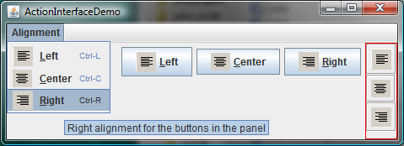

Figure 38.9
Left, Center, and Right appear in the menu, in the toolbar, and in regular buttons.

Listing 38.4 ActionInterfaceDemo.java
<margin note line 11: image icon>
<margin note line 19: create action>
<margin note line 33: menu>
<margin note line 44: toolbar>
<margin note line 52: button>
<margin note line 64: custom action>
<margin note line 67: constructor>
<margin note line 72: constructor>
<margin note line 82: handler>
<margin note line 93: main method omitted>

1 import java.awt.*;
2 import java.awt.event.*;
3 import javax.swing.*;
4
5 public class ActionInterfaceDemo extends JApplet {
6 private JPanel buttonPanel = new JPanel();
7 private FlowLayout flowLayout = new FlowLayout();
8
9 public ActionInterfaceDemo() {
10 // Create image icons
11 ImageIcon leftImageIcon = new ImageIcon(getClass().getResource(
12 "/image/leftAlignment.png"));
13 ImageIcon centerImageIcon = new ImageIcon(getClass().getResource(
14 "/image/centerAlignment.png"));
15 ImageIcon rightImageIcon = new ImageIcon(getClass().getResource(
16 "/image/rightAlignment.png"));
17
18 // Create actions
19 Action leftAction = new MyAction("Left", leftImageIcon,
20 "Left alignment for the buttons in the panel",
21 new Integer(KeyEvent.VK_L),
22 KeyStroke.getKeyStroke(KeyEvent.VK_L, ActionEvent.CTRL_MASK));
23 Action centerAction = new MyAction("Center", centerImageIcon,
24 "Center alignment for the buttons in the panel",
25 new Integer(KeyEvent.VK_C),
26 KeyStroke.getKeyStroke(KeyEvent.VK_C, ActionEvent.CTRL_MASK));
27 Action rightAction = new MyAction("Right", rightImageIcon,
28 "Right alignment for the buttons in the panel",
29 new Integer(KeyEvent.VK_R),
30 KeyStroke.getKeyStroke(KeyEvent.VK_R, ActionEvent.CTRL_MASK));
31
32 // Create menus
33 JMenuBar jMenuBar1 = new JMenuBar();
34 JMenu jmenuAlignment = new JMenu("Alignment");
35 setJMenuBar(jMenuBar1);
36 jMenuBar1.add(jmenuAlignment);
37
38 // Add actions to the menu
39 jmenuAlignment.add(leftAction);
40 jmenuAlignment.add(centerAction);
41 jmenuAlignment.add(rightAction);
42
43 // Add actions to the toolbar
44 JToolBar jToolBar1 = new JToolBar(JToolBar.VERTICAL);
45 jToolBar1.setBorder(BorderFactory.createLineBorder(Color.red));
46 jToolBar1.add(leftAction);
47 jToolBar1.add(centerAction);
48 jToolBar1.add(rightAction);
49
50 // Add buttons to the button panel
51 buttonPanel.setLayout(flowLayout);
52 JButton jbtLeft = new JButton(leftAction);
53 JButton jbtCenter = new JButton(centerAction);
54 JButton jbtRight = new JButton(rightAction);
55 buttonPanel.add(jbtLeft);
56 buttonPanel.add(jbtCenter);
57 buttonPanel.add(jbtRight);
58
59 // Add tool bar to the east and panel to the center
60 add(jToolBar1, BorderLayout.EAST);
61 add(buttonPanel, BorderLayout.CENTER);
62 }
63
64 private class MyAction extends AbstractAction {
65 String name;
66
67 MyAction(String name, Icon icon) {
68 super(name, icon);
69 this.name = name;
70 }
71
72 MyAction(String name, Icon icon, String desc, Integer mnemonic,
73 KeyStroke accelerator) {
74 super(name, icon);
75 putValue(Action.SHORT_DESCRIPTION, desc);
76 putValue(Action.MNEMONIC_KEY, mnemonic);
77 putValue(Action.ACCELERATOR_KEY, accelerator);
78 this.name = name;
79 }
80
81 @Override
82 public void actionPerformed(ActionEvent e) {
83 if (name.equals("Left"))
84 flowLayout.setAlignment(FlowLayout.LEFT);
85 else if (name.equals("Center"))
86 flowLayout.setAlignment(FlowLayout.CENTER);
87 else if (name.equals("Right"))
88 flowLayout.setAlignment(FlowLayout.RIGHT);
89
90 buttonPanel.revalidate();
91 }
92 }
93 }

The inner class MyAction extends AbstractAction with a constructor to construct an action with a name and an icon (lines 67-70) and another constructor to construct an action with a name, icon, description, mnemonic, and accelerator (lines 72-79). The constructors invoke the putValue method to associate the name, icon, decription, mnemonic, and accelerator. It implements the actionPerformed method to set a new alignment in the panel of the FlowLayout (line 82-91). The revalidate() method validates the new alignment (line 90).

Three actions, leftAction, centerAction, and rightAction, were created from the MyAction class (lines 19-30). Each action has a name, icon, decription, mnemonic, and accelerator. The actions are for the menu items and the buttons in the toolbar and in the panel. The menu and toolbar know how to add these objects automatically (lines 39-41, 46-48). Three regular buttons are created with the properties taken from the actions (lines 51-54).

38.6 JOptionPane Dialogs
You have used JOptionPane to create input and output dialog boxes. This section provides a comprehensive introduction to JOptionPane and other dialog boxes. A dialog box is normally used as a temporary window to receive additional information from the user or to provide notification that some event has occurred. Java provides the JOptionPane class, which can be used to create standard dialogs. You can also build custom dialogs by extending the JDialog class.

The JOptionPane class can be used to create four kinds of standard dialogs:

- Message dialog shows a message and waits for the user to click OK.
- Confirmation dialog shows a question and asks for confirmation, such as OK or Cancel.
- Input dialog shows a question and gets the user's input from a text field, combo box, or list.
- Option dialog shows a question and gets the user's answer from a set of options.

These dialogs are created using the static methods showXxxDialog and generally appear as shown in Figure 38.10(a).

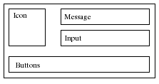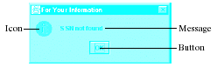
- (b)

Figure 38.10
(a) A JOptionPane dialog can display an icon, a message, an input, and option buttons. (b) The message dialog displays a message and waits for the user to click OK.

For example, you can use the following method to create a message dialog box,as shown in Figure 38.10(b):

JOptionPane.showMessageDialog(null, "SSN not found",

"For Your Information", JOptionPane.INFORMATION_MESSAGE);

38.6.1 Message Dialogs
A message dialog box displays a message that alerts the user and waits for the user to click the OK button to close the dialog. The methods for creating message dialogs are:

public static void showMessageDialog(Component parentComponent,

Object message)
public static void showMessageDialog(Component parentComponent,

Object message,

String title,
int messageType)
public static void showMessageDialog(Component parentComponent,

Object message,

String title,
int messageType,

Icon icon)

The parentComponent can be any component or null. The message is an object, but often a string is used. These two parameters must always be specified. The title is a string displayed in the title bar of the dialog with the default value "Message”.
The messageType is one of the following constants:

JOptionPane.ERROR_MESSAGE

JOptionPane.INFORMATION_MESSAGE

JOptionPane.PLAIN_MESSAGE

JOptionPane.WARNING_MESSAGE

JOptionPane.QUESTION_MESSAGE

By default, messageType is JOptionPane.INFORMATION_MESSAGE. Each type has an associated icon except the PLAIN_MESSAGE type, as shown in Figure 38.11. You can also supply your own icon in the icon parameter.

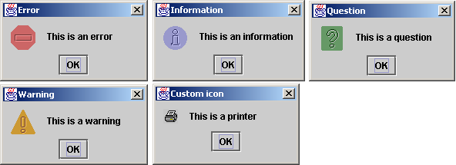

Figure 38.11
There are five types of message dialog boxes.
The message parameter is an object. If it is a GUI component, the component is displayed. If it is a non-GUI component, the string representation of the object is displayed. For example, the following statement displays a clock in a message dialog, as shown in Figure 38.12. StillClock was defined in Listing 15.10.

JOptionPane.showMessageDialog(null, new StillClock(),

"Current Time", JOptionPane.PLAIN_MESSAGE);

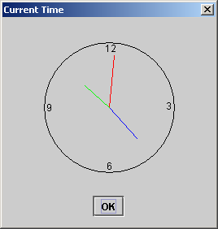

Figure 38.12
A clock is displayed in a message dialog.

38.6.2 Confirmation Dialogs
A message dialog box displays a message and waits for the user to click the OK button to dismiss the dialog. The message dialog does not return any value. A confirmation dialog asks a question and requires the user to respond with an appropriate button. The confirmation dialog returns a value that corresponds to a selected button.
The methods for creating confirmation dialogs are:

public static int showConfirmDialog(Component parentComponent,

Object message)
public static int showConfirmDialog(Component parentComponent,

Object message,

String title,
int optionType)
public static int showConfirmDialog(Component parentComponent,

Object message,

String title,
int optionType,
int messageType)
public static int showConfirmDialog(Component parentComponent,

Object message,

String title,
int optionType,
int messageType,

Icon icon)

The parameters parentComponent, message, title, icon, and messageType are the same as in the showMessageDialog method. The default value for title is "Select an Option" and for messageType is QUESTION_MESSAGE. The optionType determines which buttons are displayed in the dialog. The possible values are:

JOptionPane.YES_NO_OPTION

JOptionPane.YES_NO_CANCEL_OPTION

JOptionPane.OK_CANCEL_OPTION

Figure 38.13 shows the confirmation dialogs with these options.

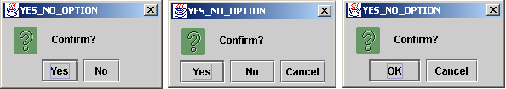

Figure 38.13
The confirmation dialog displays a question and three types of option buttons, and requires responses from the user.

The showConfirmDialog method returns one of the following int values corresponding to the selected option:

JOptionPane.YES_OPTION

JOptionPane.NO_OPTION

JOptionPane.CANCEL_OPTION

JOptionPane.OK_OPTION

JOptionPane.CLOSED_OPTION

These options correspond to the button that was activated, except for the CLOSED_OPTION, which implies that the dialog box is closed without buttons activated.

38.6.3 Input Dialogs
An input dialog box is used to receive input from the user. The input can be entered from a text field or selected from a combo box or a list. Selectable values can be specified in an array, and one of them can be designated as the initial selected value. If no selectable value is specified when an input dialog is created, a text field is used for entering input. If fewer than twenty selection values are specified, a combo box is displayed in the input dialog. If twenty or more selection values are specified, a list is used in the input dialog.
The methods for creating input dialogs are shown below:

public static String showInputDialog(Object message)
public static String showInputDialog(Component parentComponent,

Object message)
public static String showInputDialog(Component parentComponent,

Object message,

String title,
int messageType)
public static Object showInputDialog(Component parentComponent,

Object message,
int messageType,

Icon icon,

Object[] selectionValues,

Object initialSelectionValue)

The first three methods listed above use a text field for input, as shown in Figure 38.14(a). The last method listed above specifies an array of Object type as selection values in addition to an object specified as an initial selection. The first three methods return a String that is entered from the text field in the input dialog. The last method returns an Object selected from a combo box or a list. The input dialog displays a combo box if there are fewer than twenty selection values, as shown in Figure 38.14(b); it displays a list if there are twenty or more selection values, as shown in Figure 38.14(c).

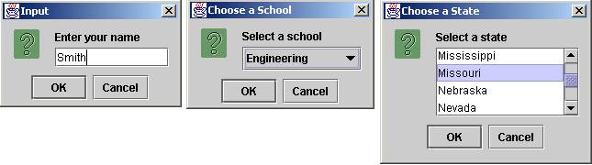
(a) text field (b) combo box (c) list

Figure 38.14
(a) When creating an input dialog without specifying selection values, the input dialog displays a text field for data entry. (b) When creating an input dialog with selection values, the input dialog displays a combo box if there are fewer than twenty selection values. (c) When creating an input dialog with selection values, the input dialog displays a list if there are twenty or more selection values.

NOTE
The showInputDialog method does not have the optionType parameter. The buttons for input dialog are not configurable. The OK and Cancel buttons are always used.

38.6.4 Option Dialogs
An option dialog allows you to create custom buttons. You can create an option dialog using the following method:

public static int showOptionDialog(Component parentComponent,

Object message,

String title,
int optionType,
int messageType,

Icon icon,

Object[] options,

Object initialValue)

The buttons are specified using the options parameter. The initialValue parameter allows you to specify a button to receive initial focus. The showOptionDialog method returns an int value indicating the button that was activated. For example, here is the code that creates an option dialog, as shown in Figure 38.15:

int value =

JOptionPane.showOptionDialog(null, "Select a button",

"Option Dialog", JOptionPane.DEFAULT_OPTION,

JOptionPane.PLAIN_MESSAGE, null,
new Object[]{"Button 0", "Button 1", "Button 2"}, "Button 1");

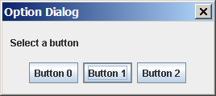

Figure 38.15

The option dialog displays the custom buttons.

38.6.5 Example: Creating JOptionPane Dialogs
This section gives an example that demonstrates the use of JOptionPane dialogs. The program prompts the user to select the annual interest rate from a list in an input dialog, the number of years from a combo box in an input dialog, and the loan amount from an input dialog, and it displays the loan payment schedule in a text area inside a JScrollPane in a message dialog, as shown in Figure 38.16.

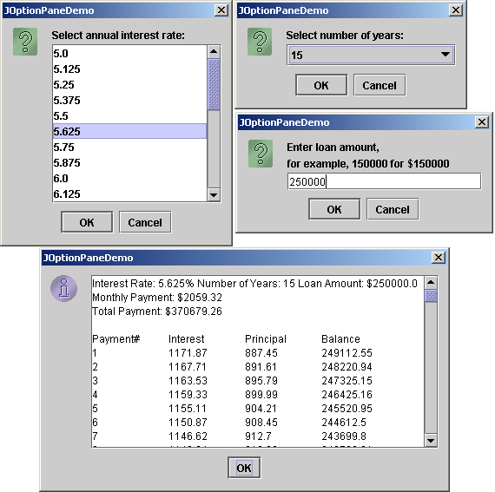

Figure 38.16
The input dialogs can contain a list or a combo box for selecting input, and the message dialogs can contain GUI objects like JScrollPane.

Here are the major steps in the program (Listing 38.5):
1. Display an input dialog box to let the user select an annual interest rate from a list.
2. Display an input dialog box to let the user select the number of years from a combo box.
3. Display an input dialog box to let the user enter the loan amount.
4. Compute the monthly payment, total payment, and loan payment schedule, and display the result in a text area in a message dialog box.

Listing 38.5 JOptionPaneDemo.java
<margin note line 12: input dialog>
<margin note line 23: input dialog>
<margin note line 29: input dialog>
<margin note line 70: message dialog>

1 import javax.swing.*;
2
3 public class JOptionPaneDemo {
4 public static void main(String args[]) {
5 // Create an array for annual interest rates
6 Object[] rateList = new Object[25];
7 int i = 0;
8 for (double rate = 5; rate <= 8; rate += 1.0 / 8)
9 rateList[i++] = new Double(rate);
10
11 // Prompt the user to select an annual interest rate
12 Object annualInterstRateObject = JOptionPane.showInputDialog(
13 null, "Select annual interest rate:", "JOptionPaneDemo",
14 JOptionPane.QUESTION_MESSAGE, null, rateList, null);
15 double annualInterestRate =
16 ((Double)annualInterstRateObject).doubleValue();
17
18 // Create an array for number of years
19 Object[] yearList = {new Integer(7), new Integer(15),
20 new Integer(30)};
21
22 // Prompt the user to enter number of years
23 Object numberOfYearsObject = JOptionPane.showInputDialog(null,
24 "Select number of years:", "JOptionPaneDemo",
25 JOptionPane.QUESTION_MESSAGE, null, yearList, null);
26 int numberOfYears = ((Integer)numberOfYearsObject).intValue();
27
28 // Prompt the user to enter loan amount
29 String loanAmountString = JOptionPane.showInputDialog(null,
30 "Enter loan amount,\nfor example, 150000 for $150000",
31 "JOptionPaneDemo", JOptionPane.QUESTION_MESSAGE);
32 double loanAmount = Double.parseDouble(loanAmountString);
33
34 // Obtain monthly payment and total payment
35 Loan loan = new Loan(
36 annualInterestRate, numberOfYears, loanAmount);
37 double monthlyPayment = loan.getMonthlyPayment();
38 double totalPayment = loan.getTotalPayment();
39
40 // Prepare output string
41 String output = "Interest Rate: " + annualInterestRate + "%" +
42 " Number of Years: " + numberOfYears + " Loan Amount: $"
43 + loanAmount;
44 output += "\nMonthly Payment: " + "$" +
45 (int)(monthlyPayment * 100) / 100.0;
46 output += "\nTotal Payment: $" +
47 (int)(monthlyPayment * 12 * numberOfYears * 100) / 100.0 + "\n";
48
49 // Obtain monthly interest rate
50 double monthlyInterestRate = annualInterestRate / 1200;
51
52 double balance = loanAmount;
53 double interest;
54 double principal;
55
56 // Display the header
57 output += "\nPayment#\tInterest\tPrincipal\tBalance\n";
58
59 for (i = 1; i <= numberOfYears * 12; i++) {
60 interest = (int)(monthlyInterestRate * balance * 100) / 100.0;
61 principal = (int)((monthlyPayment - interest) * 100) / 100.0;
62 balance = (int)((balance - principal) * 100) / 100.0;
63 output += i + "\t" + interest + "\t" + principal + "\t" +
64 balance + "\n";
65 }
66
67 // Display monthly payment and total payment
68 JScrollPane jsp = new JScrollPane(new JTextArea(output));
69 jsp.setPreferredSize(new java.awt.Dimension(400, 200));
70 JOptionPane.showMessageDialog(null, jsp,
71 "JOptionPaneDemo", JOptionPane.INFORMATION_MESSAGE, null);
72 }
73 }

The JOptionPane dialog boxes are modal, which means that no other window can be accessed until a dialog box is dismissed.

You have used the input dialog box to enter input from a text field. This example shows that input dialog boxes can also contain a list (lines 12–14) or a combo box (lines 23–25) to list input options. The elements of the list are objects. The return value from these input dialog boxes is of the Object type. To obtain a double value or an int value, you have to cast the return object into Double or Integer, then use the doubleValue or intValue method to get the double or int value (lines 15–16 and 26).

You have already used the message dialog box to display a string. This example shows that the message dialog box can also contain GUI objects. The output string is contained in a text area, the text area is inside a scroll pane, and the scroll pane is placed in the message dialog box (lines 68–71).

38.7 Creating Custom Dialogs
Standard JOptionPane dialogs are sufficient in most cases. Occasionally, you need to create custom dialogs. In Swing, the JDialog class can be extended to create custom dialogs.

As with JFrame, components are added to the contentPane of JDialog. Creating a custom dialog usually involves laying out user interface components in the dialog, adding buttons for dismissing the dialog, and installing listeners that respond to button actions.

The standard dialog is modal, which means that no other window can be accessed before the dialog is dismissed. However, the custom dialogs derived from JDialog are not modal by default. To make a dialog modal, set its modal property to true. To display an instance of JDialog, set its visible property to true.

Let us create a custom dialog box for choosing colors, as shown in Figure 38.17(a). Use this dialog to choose the color for the foreground of the button, as shown in Figure 38.17(b). When the user clicks the Change Button Text Color button, the Choose Color dialog box is displayed.

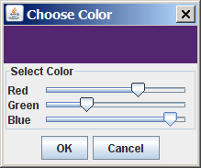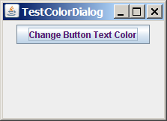
- (b)

Figure 38.17
The custom dialog allows you to choose a color for the label's foreground.

Create a custom dialog component named ColorDialog by extending JDialog. Use three sliders to specify red, green, and blue components of a color. The program is given in Listing 38.6.

Listing 38.6 ColorDialog.java
<margin note line 8: color value>
<margin note line 12: sliders>
<margin note line 17: buttons>
<margin note line 23: constructor>
<margin note line 27: constructor>
<margin note line 29: create UI>
<margin note line 69: listeners>

1 import java.awt.*;
2 import java.awt.event.*;
3 import javax.swing.*;
4 import javax.swing.event.*;
5
6 public class ColorDialog extends JDialog {
7 // Declare color component values and selected color
8 private int redValue, greenValue, blueValue;
9 private Color color = null;
10
11 // Create sliders
12 private JSlider jslRed = new JSlider(0, 128);
13 private JSlider jslGreen = new JSlider(0, 128);
14 private JSlider jslBlue = new JSlider(0, 128);
15
16 // Create two buttons
17 private JButton jbtOK = new JButton("OK");
18 private JButton jbtCancel = new JButton("Cancel");
19
20 // Create a panel to display the selected color
21 private JPanel jpSelectedColor = new JPanel();
22
23 public ColorDialog() {
24 this(null, true);
25 }
26
27 public ColorDialog(java.awt.Frame parent, boolean modal) {
28 super(parent, modal);
29 setTitle("Choose Color");
30
31 // Group two buttons OK and Cancel
32 JPanel jpButtons = new JPanel();
33 jpButtons.add(jbtOK);
34 jpButtons.add(jbtCancel);
35
36 // Group labels
37 JPanel jpLabels = new JPanel();
38 jpLabels.setLayout(new GridLayout(3, 0));
39 jpLabels.add(new JLabel("Red"));
40 jpLabels.add(new JLabel("Green"));
41 jpLabels.add(new JLabel("Blue"));
42
43 // Group sliders for selecting red, green, and blue colors
44 JPanel jpSliders = new JPanel();
45 jpSliders.setLayout(new GridLayout(3, 0));
46 jpSliders.add(jslRed);
47 jpSliders.add(jslGreen);
48 jpSliders.add(jslBlue);
49
50 // Group jpLabels and jpSliders
51 JPanel jpSelectColor = new JPanel();
52 jpSelectColor.setLayout(new BorderLayout());
53 jpSelectColor.setBorder(
54 BorderFactory.createTitledBorder("Select Color"));
55 jpSelectColor.add(jpLabels, BorderLayout.WEST);
56 jpSelectColor.add(jpSliders, BorderLayout.CENTER);
57
58 // Group jpSelectColor and jpSelectedColor
59 JPanel jpColor = new JPanel();
60 jpColor.setLayout(new BorderLayout());
61 jpColor.add(jpSelectColor, BorderLayout.SOUTH);
62 jpColor.add(jpSelectedColor, BorderLayout.CENTER);
63
64 // Place jpButtons and jpColor into the dialog box
65 add(jpButtons, BorderLayout.SOUTH);
66 add(jpColor, BorderLayout.CENTER);
67 pack();
68
69 jbtOK.addActionListener(new ActionListener() {
70 @Override
71 public void actionPerformed(ActionEvent e) {
72 setVisible(false);
73 }
74 });
75
76 jbtCancel.addActionListener(new ActionListener() {
77 @Override
78 public void actionPerformed(ActionEvent e) {
79 color = null;
80 setVisible(false);
81 }
82 });
83
84 jslRed.addChangeListener(new ChangeListener() {
85 @Override
86 public void stateChanged(ChangeEvent e) {
87 redValue = jslRed.getValue();
88 color = new Color(redValue, greenValue, blueValue);
89 jpSelectedColor.setBackground(color);
90 }
91 });
92
93 jslGreen.addChangeListener(new ChangeListener() {
94 @Override
95 public void stateChanged(ChangeEvent e) {
96 greenValue = jslGreen.getValue();
97 color = new Color(redValue, greenValue, blueValue);
98 jpSelectedColor.setBackground(color);
99 }
100 });
101
102 jslBlue.addChangeListener(new ChangeListener() {
103 @Override
104 public void stateChanged(ChangeEvent e) {
105 blueValue = jslBlue.getValue();
106 color = new Color(redValue, greenValue, blueValue);
107 jpSelectedColor.setBackground(color);
108 }
109 });
110 }
111
112 @Override
113 public Dimension getPreferredSize() {
114 return new java.awt.Dimension(200, 200);
115 }
116
117 /** Return color */
118 public Color getColor() {
119 return color;
120 }
121 }

Create a test class to use the color dialog to select the color for the foreground color of the button in Listing 38.7.

Listing 38.7 TestColorDialog.java
<margin note line 12: listener>
<margin note line 22: main method omitted>

1 import javax.swing.*;
2 import java.awt.*;
3 import java.awt.event.*;
4
5 public class TestColorDialog extends JApplet {
6 private ColorDialog colorDialog1 = new ColorDialog();
7 private JButton jbtChangeColor = new JButton("Choose color");
8
9 public TestColorDialog() {
10 setLayout(new java.awt.FlowLayout());
11 jbtChangeColor.setText("Change Button Text Color");
12 jbtChangeColor.addActionListener(new ActionListener() {
13 @Override
14 public void actionPerformed(ActionEvent e) {
15 colorDialog1.setVisible(true);
16
17 if (colorDialog1.getColor() != null)
18 jbtChangeColor.setForeground(colorDialog1.getColor());
19 }
20 });
21 add(jbtChangeColor);
22 }
23 }

The custom dialog box allows the user to use the sliders to select colors. The selected color is stored in the color variable. When the user clicks the Cancel button, color becomes null, which implies that no selection has been made.

The dialog box is displayed when the user clicks the Change Button Text Color button and is closed when the OK button or the Cancel button is clicked.

TIP: Not setting the dialog modal when needed is a common mistake. In this example, the dialog is set modal in line 24 in ColorDialog.java (Listing 38.6). If the dialog is not modal, all the statements in the Change Button Text Color button handler are executed before the color is selected from the dialog box.

38.8 JColorChooser
You created a color dialog in the preceding example as a subclass of JDialog, which is a subclass of java.awt.Dialog (a top-level heavy-weight component). Therefore, it cannot be added to a container as a component. Color dialogs are commonly used in GUI programming. Swing provides a convenient and versatile color dialog named javax.swing.JColorChooser. JColorChooser is a lightweight component inherited from JComponent. It can be added to any container. For example, the following code places a JColorChooser in an applet, as shown in Figure 38.18.

<margin note line 3: create JColorChooser>
public class JColorChooserDemo extends javax.swing.JApplet {
public JColorChooserDemo() {
this.add(new javax.swing.JColorChooser());
}
}

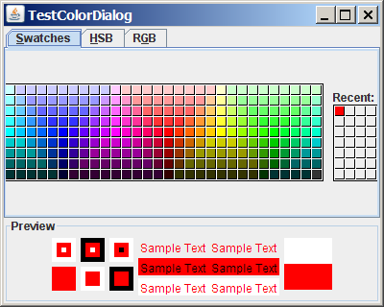

Figure 38.18

An instance of JColorChooser is displayed in an applet; (b)

Often an instance of JColorChooser is displayed in a dialog box using JColorChooser's static showDialog method:

public static Color showDialog(Component parentComponent,

String title,

Color initialColor)

For example, the following code displays a JColorChooser, as shown in Figure 38.18.

Color color = JColorChooser.showDialog(this, "Choose a color",

Color.YELLOW);

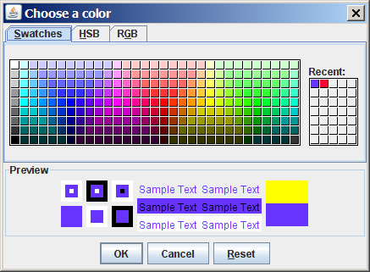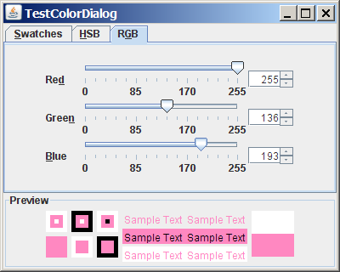
(a) (b)

Figure 38.19
An instance of JColorChooser is displayed in a dialog box with the OK, Cancel, and Reset buttons.

The showDialog method creates an instance of JDialog with three buttons, OK, Cancel, and Reset, to hold a JColorChooser object, as shown in Figure 38.19(a). The method displays a modal dialog. If the user clicks the OK button, the method dismisses the dialog and returns the selected color. If the user clicks the Cancel button or closes the dialog, the method dismisses the dialog and returns null.

JColorChooser consists of a tabbed pane and a color preview panel. The tabbed pane has three tabs for choosing colors using Swatches, HSB, and RGB, as shown in Figure 38.19(b). The preview panel shows the effect of the selected color.

NOTE: JColorChooser is very flexible. It allows you to replace the tabbed pane or the color preview panel with custom components. The default tabbed pane and the color preview panel are sufficient. You rarely need to use custom components.

38.9 JFileChooser
The javax.swing.JFileChooser class displays a dialog box from which the user can navigate through the file system and select files for loading or saving, as shown in Figure 38.20.

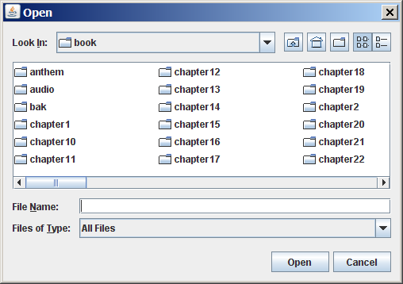

Figure 38.20
The Swing JFileChooser shows files and directories, and enables the user to navigate through the file system visually.

Like JColorChooser, JFileChooser is a lightweight component inherited from JComponent. It can be added to any container if desired, but often you create an instance of JFileChooser and display it standalone.

JFileChooser is a subclass of JComponent. There are several ways to construct a file dialog box. The simplest is to use JFileChooser's no-arg constructor.

The file dialog box can appear in two types: open and save. The open type is for opening a file, and the save type is for storing a file. To create an open file dialog, use the following method:

public int showOpenDialog(Component parent)

This method creates a dialog box that contains an instance of JFileChooser for opening a file. The method returns an int value, either APPROVE_OPTION or CANCEL_OPTION, which indicates whether the Open button or the Cancel button was clicked.
Similarly, you can use the following method to create a dialog for saving files:

public int showSaveDialog(Component parent)

The file dialog box created with showOpenDialog or showSaveDialog is modal. The JFileChooser class has the properties inherited from JComponent. It also has the following useful properties:

- dialogType specifies the type of this dialog. Use OPEN_DIALOG when you want to bring up a file chooser that the user can use to open a file. Likewise, use SAVE_DIALOG to let the user choose a file for saving.
- dialogTitle is the string that is displayed in the title bar of the dialog box.
- currentDirectory is the current directory of the file. The type of this property is java.io.File. If you want the current directory to be used, use setCurrentDirectory(new File(".")).
- selectedFile is the file you have selected. You can use getSelectedFile() to return the selected file from the dialog box. The type of this property is java.io.File. If you have a default file name that you expect to use, use setSelectedFile(new File(filename)).
- multiSelectionEnabled is a boolean value indicating whether multiple files can be selected. By default, it is false.
- selectedFiles is a list of the files selected if the file chooser is set to allow multi-selection. The type of this property is File[].

Let us create an example of a simple text editor that uses Swing menus, toolbar, file chooser, and color chooser, as shown in Figure 38.21, which allows the user to open and save text files, clear text, and change the color and font of the text. Listing 38.8 shows the program.

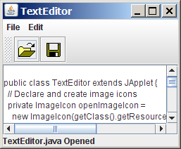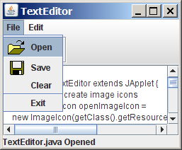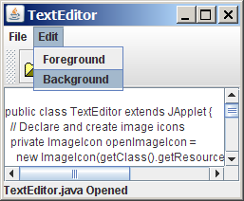

Figure 38.21
The editor enables you to open and save text files from the File menu or from the toolbar, and to change the color and font of the text from the Edit menu.

Listing 38.8 TextEditor.java
<margin note line 33: create UI>
<margin note line 88: color chooser>
<margin note line 100: color chooser>
<margin note line 112: file chooser>
<margin note line 119: file chooser>
<margin note line 182: main method omitted>

1 import java.io.*;
2 import java.awt.*;
3 import java.awt.event.*;
4 import javax.swing.*;
5
6 public class TextEditor extends JApplet {
7 // Declare and create image icons
8 private ImageIcon openImageIcon =
9 new ImageIcon(getClass().getResource("/image/open.gif"));
10 private ImageIcon saveImageIcon =
11 new ImageIcon(getClass().getResource("/image/save.gif"));
12
13 // Create menu items
14 private JMenuItem jmiOpen = new JMenuItem("Open", openImageIcon);
15 private JMenuItem jmiSave = new JMenuItem("Save", saveImageIcon);
16 private JMenuItem jmiClear = new JMenuItem("Clear");
17 private JMenuItem jmiExit = new JMenuItem("Exit");
18 private JMenuItem jmiForeground = new JMenuItem("Foreground");
19 private JMenuItem jmiBackground = new JMenuItem("Background");
20
21 // Create buttons to be placed in a tool bar
22 private JButton jbtOpen = new JButton(openImageIcon);
23 private JButton jbtSave = new JButton(saveImageIcon);
24 private JLabel jlblStatus = new JLabel();
25
26 // Create a JFileChooser with the current directory
27 private JFileChooser jFileChooser1
28 = new JFileChooser(new File("."));
29
30 // Create a text area
31 private JTextArea jta = new JTextArea();
32
33 public TextEditor() {
34 // Add menu items to the menu
35 JMenu jMenu1 = new JMenu("File");
36 jMenu1.add(jmiOpen);
37 jMenu1.add(jmiSave);
38 jMenu1.add(jmiClear);
39 jMenu1.addSeparator();
40 jMenu1.add(jmiExit);
41
42 // Add menu items to the menu
43 JMenu jMenu2 = new JMenu("Edit");
44 jMenu2.add(jmiForeground);
45 jMenu2.add(jmiBackground);
46
47 // Add menus to the menu bar
48 JMenuBar jMenuBar1 = new JMenuBar();
49 jMenuBar1.add(jMenu1);
50 jMenuBar1.add(jMenu2);
51
52 // Set the menu bar
53 setJMenuBar(jMenuBar1);
54
55 // Create tool bar
56 JToolBar jToolBar1 = new JToolBar();
57 jToolBar1.add(jbtOpen);
58 jToolBar1.add(jbtSave);
59
60 jmiOpen.addActionListener(new ActionListener() {
61 @Override
62 public void actionPerformed(ActionEvent e) {
63 open();
64 }
65 });
66
67 jmiSave.addActionListener(new ActionListener() {
68 @Override
69 public void actionPerformed(ActionEvent evt) {
70 save();
71 }
72 });
73
74 jmiClear.addActionListener(new ActionListener() {
75 @Override
76 public void actionPerformed(ActionEvent evt) {
77 jta.setText(null);
78 }
79 });
80
81 jmiExit.addActionListener(new ActionListener() {
82 @Override
83 public void actionPerformed(ActionEvent evt) {
84 System.exit(0);
85 }
86 });
87
88 jmiForeground.addActionListener(new ActionListener() {
89 @Override
90 public void actionPerformed(ActionEvent evt) {
91 Color selectedColor =
92 JColorChooser.showDialog(null, "Choose Foreground Color",
93 jta.getForeground());
94
95 if (selectedColor != null)
96 jta.setForeground(selectedColor);
97 }
98 });
99
100 jmiBackground.addActionListener(new ActionListener() {
101 @Override
102 public void actionPerformed(ActionEvent evt) {
103 Color selectedColor =
104 JColorChooser.showDialog(null, "Choose Background Color",
105 jta.getForeground());
106
107 if (selectedColor != null)
108 jta.setBackground(selectedColor);
109 }
110 });
111
112 jbtOpen.addActionListener(new ActionListener() {
113 @Override
114 public void actionPerformed(ActionEvent evt) {
115 open();
116 }
117 });
118
119 jbtSave.addActionListener(new ActionListener() {
120 @Override
121 public void actionPerformed(ActionEvent evt) {
122 save();
123 }
124 });
125
126 add(jToolBar1, BorderLayout.NORTH);
127 add(jlblStatus, BorderLayout.SOUTH);
128 add(new JScrollPane(jta), BorderLayout.CENTER);
129 }
130
131 /** Open file */
132 private void open() {
133 if (jFileChooser1.showOpenDialog(this) ==
134 JFileChooser.APPROVE_OPTION)
135 open(jFileChooser1.getSelectedFile());
136 }
137
138 /** Open file with the specified File instance */
139 private void open(File file) {
140 try {
141 // Read from the specified file and store it in jta
142 BufferedInputStream in = new BufferedInputStream(
143 new FileInputStream(file));
144 byte[] b = new byte[in.available()];
145 in.read(b, 0, b.length);
146 jta.append(new String(b, 0, b.length));
147 in.close();
148
149 // Display the status of the Open file operation in jlblStatus
150 jlblStatus.setText(file.getName() + " Opened");
151 }
152 catch (IOException ex) {
153 jlblStatus.setText("Error opening " + file.getName());
154 }
155 }
156
157 /** Save file */
158 private void save() {
159 if (jFileChooser1.showSaveDialog(this) ==
160 JFileChooser.APPROVE_OPTION) {
161 save(jFileChooser1.getSelectedFile());
162 }
163 }
164
165 /** Save file with specified File instance */
166 private void save(File file) {
167 try {
168 // Write the text in jta to the specified file
169 BufferedOutputStream out = new BufferedOutputStream(
170 new FileOutputStream(file));
171 byte[] b = (jta.getText()).getBytes();
172 out.write(b, 0, b.length);
173 out.close();
174
175 // Display the status of the save file operation in jlblStatus
176 jlblStatus.setText(file.getName() + " Saved ");
177 }
178 catch (IOException ex) {
179 jlblStatus.setText("Error saving " + file.getName());
180 }
181 }
182 }

The program creates the File and Edit menus (lines 34-45). The File menu contains the menu commands Open for loading a file, Save for saving a file, Clear for clearing the text editor, and Exit for terminating the program. The Edit menu contains the menu commands Foreground Color and Background Color for setting foreground color and background color in the text. The Open and Save menu commands can also be accessed from the toolbar, which is created in lines 56-58. The status of executing Open and Save is displayed in the status label, which is created in line 24.

jFileChooser1, an instance of JFileChooser, is created for displaying the file dialog box to open and save files (lines 27-28). new File(".") is used to set the current directory to the directory where the class is stored.

The open method is invoked when the user clicks the Open menu command or the Open toolbar button (lines 62, 108). The showOpenDialog method (line 125) displays an Open dialog box, as shown in Figure 38.20. Upon receiving the selected file, the method open(file) (line 127) is invoked to load the file to the text area using a BufferedInputStream wrapped on a FileInputStream.

The save method is invoked when the user clicks the Save menu command or the Save toolbar button (lines 68, 114). The showSaveDialog method (line 151) displays a Save dialog box. Upon receiving the selected file, the method save(file) (line 153) is invoked to save the contents from the text area to the file, using a BufferedOutputStream wrapped on a FileOutputStream.

The color dialog is displayed using the static method showDialog (lines 87, 98) of JColorChooser. Thus you don't need to create an instance of JFileChooser. The showDialog method returns the selected color if the OK button is clicked after a color is selected.

Chapter Summary
- Menus make selection easier and are widely used in window applications. Java provides five classes that implement menus: JMenuBar, JMenu, JMenuItem, JCheckBoxMenuItem, and JRadioButtonMenuItem. These classes are subclasses of AbstractButton. They are very similar to buttons.

- JMenuBar is a top-level menu component used to hold menus. A menu consists of menu items that the user can select (or toggle on or off). A menu item can be an instance of JMenuItem, JCheckBoxMenuItem, or JRadioButtonMenuItem. Menu items can be associated with icons, keyboard mnemonics, and keyboard accelerators. Menu items can be separated using separators.

- A popup menu, also known as a context menu, is like a regular menu, but does not have a menu bar and can float anywhere on the screen. Creating a popup menu is similar to creating a regular menu. First, you create an instance of JPopupMenu, then you can add JMenuItem, JCheckBoxMenuItem, JRadioButtonMenuItem, and separators to the popup menu.

- Customarily, you display a popup menu by pointing to a GUI component and clicking a certain mouse button, the so-called popup trigger. Popup triggers are system dependent. In Windows, the popup menu is displayed when the right mouse button is released. In Motif, the popup menu is displayed when the third mouse button is pressed and held down.

- Swing provides the JToolBar class as the container to hold toolbar components. JToolBar uses BoxLayout to manage components. The components usually appear as icons. Since icons are not components, they cannot be placed into a toolbar directly. Instead you place buttons into the toolbar and set the icons on the buttons. An instance of JToolBar is like a regular container. Often it is placed in the north, west, or east of a container of BorderLayout.

- Swing provides the Action interface, which can be used to create action objects for processing actions. Using Action objects, common action processing for menu items and toolbar buttons can be centralized and separated from the other application code.

- The JOptionPane class contains the static methods for creating message dialogs, confirmation dialogs, input dialogs, and option dialogs. You can also create custom dialogs by extending the JDialog class.

- Swing provides a convenient and versatile color dialog named javax.swing.JColorChooser. Like JOptionPane, JColorChooser is a lightweight component inherited from JComponent. It can be added to any container.

- Swing provides the javax.swing.JFileChooser class that displays a dialog box from which the user can navigate through the file system and select files for loading or saving.

Test Questions
Do the test questions for this chapter online at www.cs.armstrong.edu/liang/intro9e/test.html.

Review Questions

Section 38.2
38.1 How do you create a menu bar?
38.2 How do you create a submenu? How do you create a check-box menu item? How do you create a radio-button menu item?
38.3 How do you add a separator in a menu?
38.4 How do you set an icon and a text in a menu item? How do you associate keyboard mnemonics and accelerators in a menu item?

Section 38.3
38.5 How do you create a popup menu? How do you show a popup menu?
38.6 Describe a popup trigger.

Section 38.4
38.7 What is the layout manager used in JToolBar? Can you change the layout manager?
38.8 How do you add buttons into a JToolBar? How do you add a JToolBar into a frame or an applet?

Section 38.5
38.9 What is the Action interface for?
38.10 How do you add an Action object to a JToolBar, JMenu, JButton, JRadioButton, and JCheckBox?

Section 38.6
38.11 Describe the standard dialog boxes created using the JOptionPane class.
38.12 How do you create a message dialog? What are the message types? What is the button in the message dialog?
38.13 How do you create a confirmation dialog? What are the button option types?
38.14 How do you create an input dialog with a text field for entering input? How do you create a combo box dialog for selecting values as input? How do you create a list dialog for selecting values as input?

Sections 38.7-38.10
38.15 How do you show an instance of JDialog? Is a standard dialog box created using the static methods in JOptionPane modal? Is an instance of JDialog modal?
38.16 How do you display an instance of JColorChooser? Is an instance of JColorChooser modal? How do you obtain the selected color?
38.17 How do you display an instance of JFileChooser? Is an instance of JFileChooser modal? How do you obtain the selected file? What is the return type for getSelectedFile() and getSelectedDirectory()? How do you set the current directory as the default directory for a JFileChooser dialog?

Programming Exercises

Sections 38.2-38.3
38.1*
(Create an investment value calculator) Write a program that calculates the future value of an investment at a given interest rate for a specified number of years. The formula for the calculation is as follows:

futureValue = investmentAmount × (1 + monthlyInterestRate)years×12

Use text fields for interest rate, investment amount, and years. Display the future amount in a text field when the user clicks the Calculate button or chooses Calculate from the Operation menu (see Figure 38.22). Show a message dialog box when the user clicks the About menu item from the Help menu.

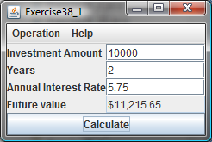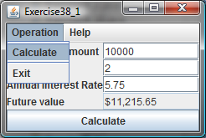

Figure 38.22
The user enters the investment amount, years, and interest rate to compute future value.

38.2*
(Use popup menus) Modify Listing 38.1, MenuDemo.java, to create a popup menu that contains the menus Operations and Exit, as shown in Figure 38.23. The popup is displayed when you click the right mouse button on the panel that contains the labels and the text fields.

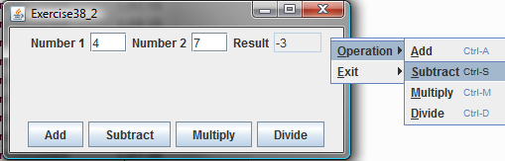

Figure 38.23
The popup menu contains the commands to perform arithmetic operations.

Sections 38.4-38.5
38.3**
(A paint utility) Write a program that emulates a paint utility. Your program should enable the user to choose options and draw shapes or get characters from the keyboard based on the selected options (see Figure 38.24). The options are displayed in a toolbar. To draw a line, the user first clicks the line icon in the toolbar and then uses the mouse to draw a line in the same way you would draw using Microsoft Paint.

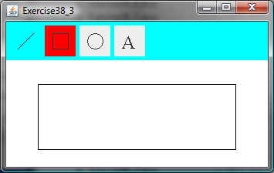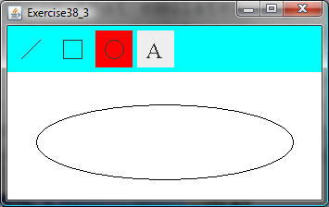

Figure 38.24
This exercise produces a prototype drawing utility that enables you to draw lines, rectangles, ovals, and characters.

38.4*
(Use actions) Write a program that contains the menu items and toolbar buttons that can be used to select flags to be displayed in an ImageViewer, as shown in Figure 38.25. Use the Action interface to centralize the processing for the actions.

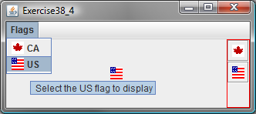

Figure 38.25
The menu items and tool buttons are used to display selected images in the ImageViewer.

Sections 38.6-38.10
38.5*
(Demonstrate JOptionPane) Write a program that creates option panes of all types, as shown in Figure 38.26. Each menu item invokes a static showXxxDialog method to display a dialog box.

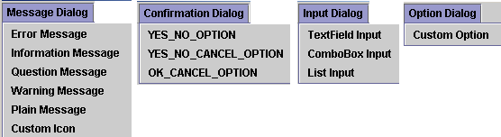

Figure 38.26
You can display a dialog box by clicking a menu item.

38.6*
(Create custom dialog) Write a program that creates a custom dialog box to gather user information, as shown in Figure 38.27(a).

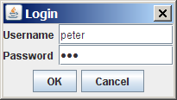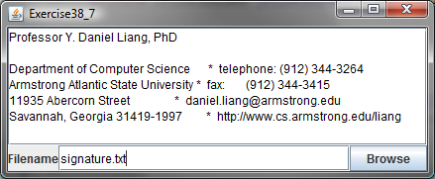
(a) (b)

Figure 38.27
(a) The custom dialog box prompts the user to enter username and password. (b) The program enables the user to view a file by selecting it from a file open dialog box.

38.7*

(Use JFileChooser) Write a program that enables the user to select a file from a file open dialog box. A file open dialog box is displayed when the Browse button is clicked, as shown in Figure 38.27(b). The file is displayed in the text area, and the file name is displayed in the text field when the OK button is clicked in the file open dialog box. You can also enter the file name in the text field and press the Enter key to display the file in the text area.

38.8*
(Select an audio file) Write a program that selects an audio file using the file dialog box, and use three buttons, Play, Loop, and Stop, to control the audio, as shown in Figure 38.28. If you click the Play button, the audio file is played once. If you click the Loop button, the audio file keeps playing repeatedly. If you click the Stop button, the playing stops. The selected audio files are stored in the folder named anthems under the exercise directory. The exercise directory contains the class file for this exercise.

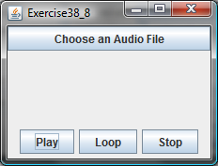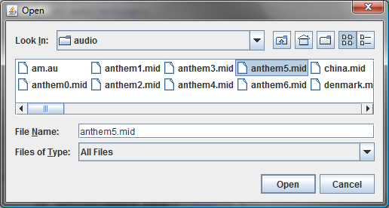

Figure 38.28
The program allows you to choose an audio file from a dialog box and use the buttons to play, repeatedly play, or stop the audio.

38.9**
(Play TicTacToe with a computer) The game in §18.9, “Case Study: TicTacToe,” facilitates two players. Write a new game that enables a player to play against the computer. Add a File menu with two items, New Game and Exit, as shown in Figure 38.29. When you click New Game, it displays a dialog box. From this dialog box, you can decide whether to let the computer go first.

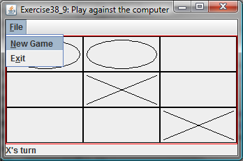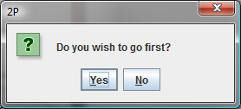

Figure 38.29
The new TicTacToe game enables you to play against the computer.

